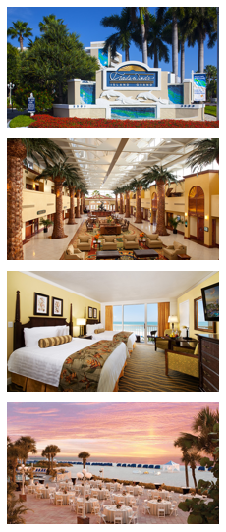
Great Venue • Great Content • Great Value
Great Venue
For the 2022 conference, we are remaining where many Xplorers say the ‘best years’ of Xplor’s modern conferences are. The event is being held at the TradeWinds Island Grand Resort in sunny
St. Petersburg, Florida.
Our group rate is $219 USD per night, which includes the resort fee and internet. St. Pete Beach was named the No. 1 beach in America by Tripadvisor in its annual Travelers’ Choice Awards.
Great Content
The conference program features three areas of focus, which included Industry Trends/Best Practices, Technology, and Customer Engagement. Each track is a unique blend of general and breakout sessions that address specific topics which drive the CCM and digital document industries.
Great Value
Starting at $899 USD for members, XPLOR22 is an amazing value! Over 40 educational sessions to expand your knowledge, two lunches, a breakfast, and two evening events to expand your network, and access to leading-edge technologies in the vendor forum.
Who Should Attend?  If you are reading this, YOU!  Anyone involved in the design, creation,  production, or distribution of  customer communications. | First Timer?  Never been to an annual conference before?  You may qualify for a FREE Platinum Passport!  Our First Timer Recognition Program is now open so go to the link below for more information!
For more information about XPLOR22, the First Timer Recognition Program, and speaking or exhibiting opportunities, please visit www.xplor.org/XPLOR22.

