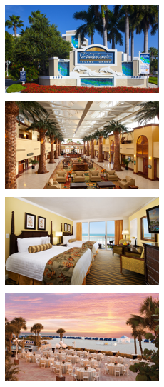
Great Venue • Great Content • Great Value
Great Venue
For the 2020 conference, we are going back to basics to where many Xplorers say the ‘best years’ of Xplor’s modern conferences were. The event is being held at the TradeWinds Island Grand Resort in sunny
St. Pete Beach, Florida.
Our group rate is $199 USD per night, which includes the resort fee and internet. This is a savings of over 50% off the best available rate!
Great Content
The conference program features five areas of focus, each with a unique blend of general and breakout sessions that address best practices and processes driving the CCM and digital document industries.
Great Value
Starting at $899 USD for members, XPLOR20 is an amazing value! Over 40 educational sessions to expand your knowledge, two lunches, a breakfast, and two evening events to expand your network, and access to leading-edge technologies in the vendor forum.
Who Should Attend?  If you are reading this, YOU!  Anyone involved in the design, creation,  production, or distribution of  customer communications. | First Timer?  Never been to an annual conference before?  You may qualify for a FREE Platinum Passport!  Our First Timer Recognition Program is now open so go to the link below for more information!
For more information about XPLOR20, the First Timer Recognition Program, and speaking or exhibiting opportunities, please visit www.xplor.org/XPLOR20.

