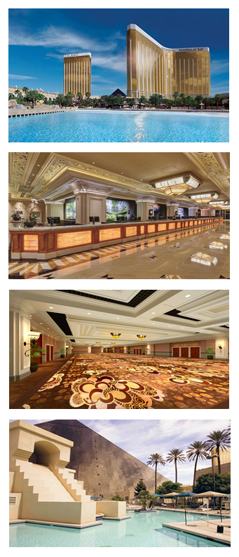
New Format • New Location• New Agenda
New Format
For 2019 we are flipping things around by starting conference sessions on Tuesday afternoon at 5:00 pm followed by our opening reception from 7:00-9:00 pm. The conference format blends general and breakout sessions with daily networking opportunities.
New Location
The event is being held at the beautiful Mandalay Bay Hotel and Conference Center in Las Vegas.
Rooms are available at four MGM venues including the Delano, Mandalay Bay, Luxor and Excalibur with room rates ranging between $89-$159 per night. All are in close proximity to the conference center and there is a price point for every budget.
New Agenda
The conference program features three educational tracks, with a unique blend of general and breakout sessions. Tracks include business, delivery, and marketing. Sessions will focus on best practices, technologies and processes driving the CCM and digital document industries.
Who Should Attend?  If you are reading this, YOU!  Anyone involved in the design, creation,  production, or distribution of digital documents  and/or customer communications. | First Timer?  Never been to an annual conference before?  You may qualify for a FREE Platinum Passport!  Our First Timer Recognition Program is now open so go to the link below for more information!
For more information about XPLOR19, the First Timer Recognition Program, and Speaking or Exhibiting Opportunities, please visit www.xplor.org/XPLOR19

